**PRACTICAL - 5**

**AIM:**

|  |
| --- |
| **An electric appliance shop assigns code 1 to motor,2to fan,3 to tube and 4 for wires. All other items have code 5 or more. While selling the goods, a sales tax of 8% to motor,12% to fan,5% to tube light,7.5% to wires and 3% for all other items is charged. A list containing the product code and price in two different arrays. Write a java program using switch statement to prepare the bill.** |

**SOURCE CODE:**

import java.util.Scanner;

public class Practical5 {

    public static *void* main(String[] *args*) {

*int* rs;

*short* code[] = { 1, 2, 3, 4, 5 };

*float* tax[] = { 8, 12, 5, 7.5f, 3 };

*int* price[] = { 149, 299, 49, 449, 799 };

        System.out.println("1. Motor (Rs.149 + Tax = Rs.8)");

        System.out.println("2. fan (Rs.299 + Tax = Rs.12)");

        System.out.println("3. Tube (Rs.49 + Tax = Rs.5)");

        System.out.println("4. Wire (Rs.449 + Tax = Rs. 7.5)");

        System.out.println("5. Other Product (Rs.799 + Tax = Rs.3)");

        System.out.println("\nEnter Product Code: ");

        Scanner sc = new Scanner(System.in);

*int* i = sc.nextInt();

        switch (i) {

          case 1:

          rs = (*int*) (price[i - 1] + price[i - 1] * tax[i - 1] / 100);

          break;

          case 2:

          rs = (*int*) (price[i - 1] + price[i - 1] * tax[i - 1] / 100);

          break;

          case 3:

          rs = (*int*) (price[i - 1] + price[i - 1] * tax[i - 1] / 100);

          break;

          case 4:

          rs = (*int*) (price[i - 1] + price[i - 1] * tax[i - 1] / 100);

          break;

          default:

          rs = (*int*) (price[i - 1] + price[i - 1] * tax[i - 1] / 100);

        }

        System.out.println("\n<----Bill---->");

        System.out.println("Total amount is: " + rs);

        System.out.println("\n20DCE019-Yatharth Chauhan");

    }

}

**OUTPUT:**

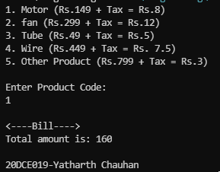

**CONCLUSION:**

* In this Practical We learnt the use of switch statement.